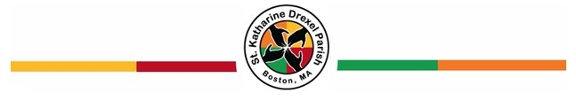

St. Katharine Drexel Parish First Holy Communion Preparation Program

(PLEASE PRINT NEATLY)

Date:
Name:
First, Middle, Last

Address:

Phone Number:
Birth Date:

Father’s First and Last Name:

Mother’s First, Last and Maiden Name:

Parent(s) E-Mail Address:

Sacramental Information:

Date and Parish your child was baptized:
**If your child was baptized outside of the United States, please include a copy of their certificate of baptism.

Mail the completed application to:
Saint Katharine Drexel Parish Center
Attn: Office Manager/Parish Life Coordinator
175 Ruggles Street, Roxbury, MA 02120
Or
Email this completed application to info@stkdparish.org with subject “First Communion Application” and notify the parish office at 617-445-8915 that the application was emailed.

You will be contacted once the application has been received.

