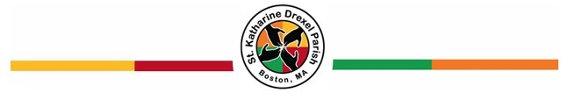
St. Katharine Drexel Parish Confirmation Preparation Program

(PLEASE PRINT NEATLY)

Date: _____________________________

Name: ____________________________________________________________________________
First Middle Last

Address: _______________________________________________________________________

_______________________________________________________________________

Phone Number: _____________________________ Birthdate: _____________________________

Youth’s E-Mail: _______________________________________ Year of Graduation: ____________

Father’s First and Last Name: __________________________________________________________

Mother’s First, Last and Maiden Name: ___________________________________________________

Parent(s) E-Mail Address: _____________________________________________________________

Sacramental Information:
Date and Parish you were baptized: _______________________________________________

Parish you received your First Communion: _________________________________________

Sponsor Information:
Sponsor’s Name: _____________________________________________________________

Sponsor’s Address: ___________________________________________________________

Sponsor’s Phone Number: ___________________ Sponsor’s E-Mail: __________________

Sponsor’s Parish: _____________________________________________________________

Why did you pick this person as your sponsor?_______________________________________

____________________________________________________________________________

Confirmation Name:
Confirmation Name: ___________________________________________________________

Why this Confirmation Name? ___________________________________________________

____________________________________________________________________________

Mail the completed application to:
Saint Katharine Drexel Parish Center
Attn: Office Manager/Parish Life Coordinator
175 Ruggles Street, Roxbury, MA 02120

