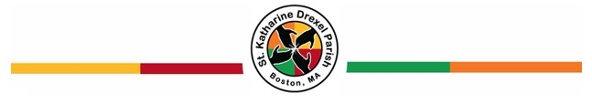

St. Katharine Drexel Parish First Holy Communion Preparation Program

(PLEASE PRINT NEATLY)

Date: _____________________________

Name: ____________________________________________________________________________
First Middle Last

Address: _______________________________________________________________________

_______________________________________________________________________

Phone Number: _____________________________

Birthdate: _____________________________

Father’s First and Last Name:

__________________________________________________________

Mother’s First, Last and Maiden Name:

___________________________________________________

Parent(s) E-Mail Address:

_____________________________________________________________

Sacramental Information:

Date and Parish your child was baptized:

_____________________________________________________________
**If your child was baptized outside of the United States, please include a copy of their certificate of baptism.

Mail the completed application to:
Saint Katharine Drexel Parish Center
Attn: Office Manager/Parish Life Coordinator
175 Ruggles Street, Roxbury, MA 02120

